**《科技英语实训》课程复习范围：**

ⅠMultiple Choices(2’×10=20’)

题型：单选题

范围：第二章到第四章内容，包括线上PDF文档内容与章节测验。

**Samples:**

1. between two sentences means the second sentence conveys contrastive information with the first one.
2. Additive relation B. Adversative relation

C. Causal relation D. Temporal relation

1. Which way of word formation is used in the word “COVID-19” ?
2. Conversion B. abbreviation C. derivation D. compounding

Ⅱ EST Translation(5’×8=40’)

题型：英译汉

范围：第五章内容，具体复习范围(30个句子，第13周由任课老师发给学生），30个句子来自本章线上内容，从中选6个句子，课外2个句子）。

Ⅲ Abstract Reorganization(10’×2=20’)

题型：2个摘要排序题，每个摘要包含5个句子。答案填涂方式：在横线处填上正确的句子序号，排好序的段落构成一个完整的摘要，如：5-1-3-2-4 。

范围：第六章内容，其中一个摘要来自课内（第六章线上内容，包含线上PDF文档与章节测验。），另一个来自课外。

Ⅳ Writing(20’×1=20’)

题型：表格内容评述，字数要求：Write about 120 words.

范围：来自课外，参考第七章内容。

Sample:

**Directions:** The table below gives information about the underground railway systems in six cities. Summarize the information by selecting and reporting the main features, and make comparisons where relevant.

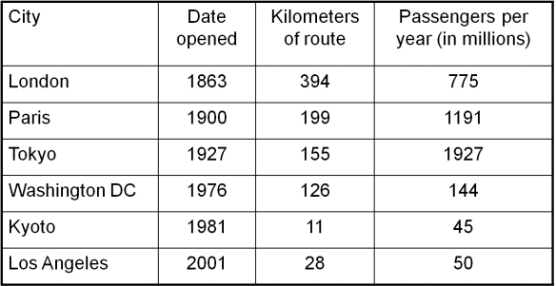

**范文：**

The table shows the details regarding the underground railway systems in six cities.

London has the oldest underground railway system among the six cities and it was opened in the year 1863. Paris has the second oldest system (in 1900), followed by the opening of the railway systems in Tokyo, Washington DC and Kyoto. The subway in Los Angeles is the newest, and it was opened in 2001.

The route of underground railway in London is the longest, at 394 kilometers, which is nearly twice as long as the system in Paris. The length of Washington is 126 kilometers and Kyoto has the smallest system (11 kilometers).

Although Tokyo only has 155 kilometers of route, it serves the greatest number of people every year (1927 million). The system in Paris has the second greatest number of passengers, at 1191 million. The number of passengers in London is 5 times as many as that in Washington and Kyoto has the smallest number of passengers (45 million).

In conclusion, the underground railway systems in the six cities are very different in their age, length and the number of passengers.